Partial exam
- data structures -

Exercise 1
5 min

3p a) You are given the following structure, representing a node in a Singly Linked List:
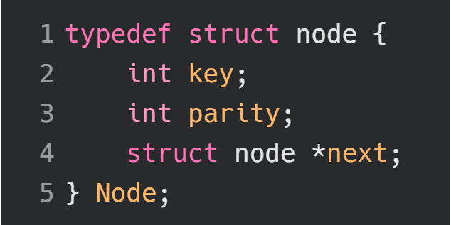
You are also given a function that creates a new node in the list:
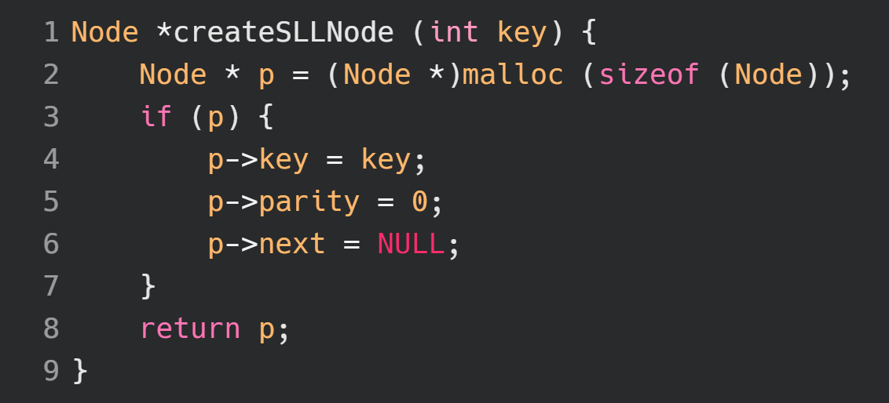
Write a function that marks every even node in the list by setting the parity property to 1 and has the following signature, where root is the first node in the list:

void markEven(Node* root);

Note: Parity does not depend on the value of the key property. It depends on the position of the node in the list.

1p b) What is the name of the memory area in which variables are stored when initialized with malloc?
Exercise 2
12 min

4p a) You are given the following structures which represent a Doubly Linked List header and node:
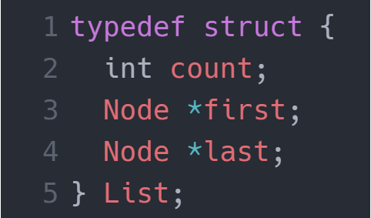
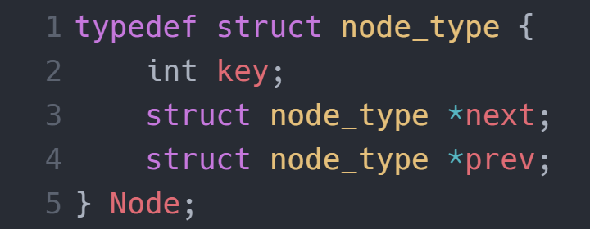
The following function tries to insert a new node into a Doubly Linked List, at the front, but something is missing. The function isEmpty() returns 1 if the list has no node and 0 if it has at least one node. Add the missing code at line 7.
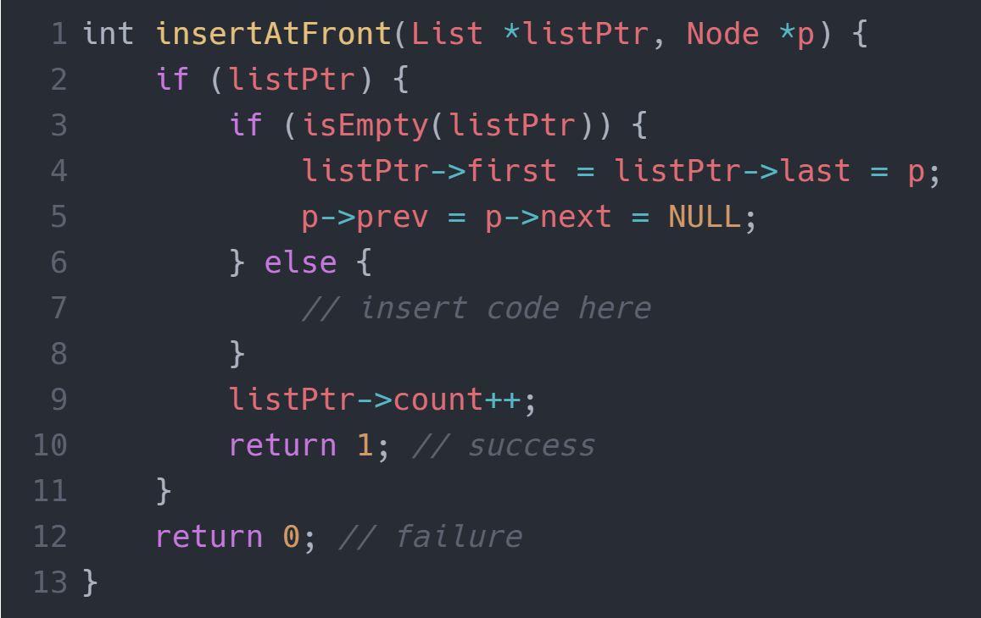
2p b) The structure of the node has changed and now has a new property called “parity” which is initially 0:
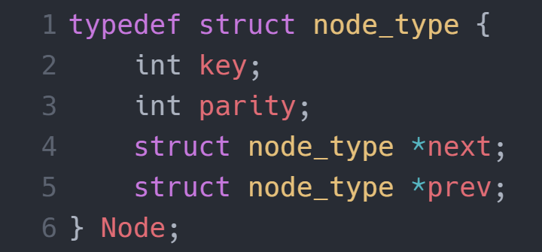
You are given the following function which tries to insert a node at the end of the list with a twist. Mark the newly added node’s parity with 1 if it is on an even position and 0 if it is on an odd position in the Doubly Linked List. You can assume that the other nodes have the correct parity.
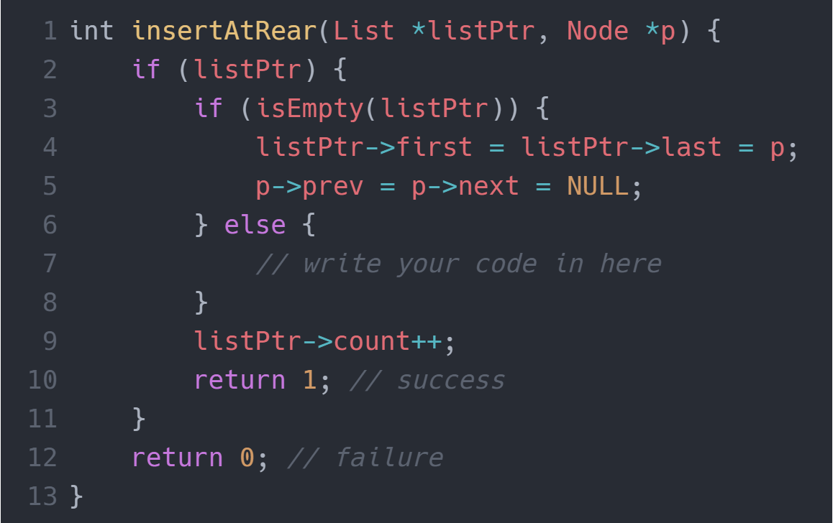
Note: Parity does not depend on the value of the key property. It depends on the position of the node in the list.
Exercise 3
6 min

1p a) Tell me your opinion on the following topics in as few words as possible:
- What are binary trees used for?
- Describe an application for which you would use a hash table to represent the data.

1p b) Write down the preorder traversal of this Binary Search Tree:
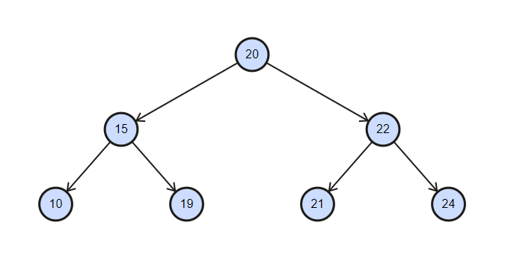
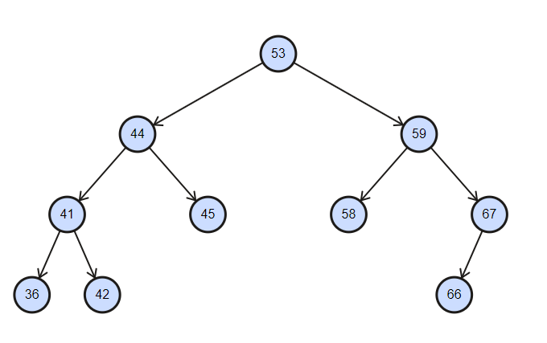
1p c) Write down the postorder traversal of this Binary Search Tree:

1p d) Write the inorder traversal for this Binary Search Tree and compute the sum of its elements:
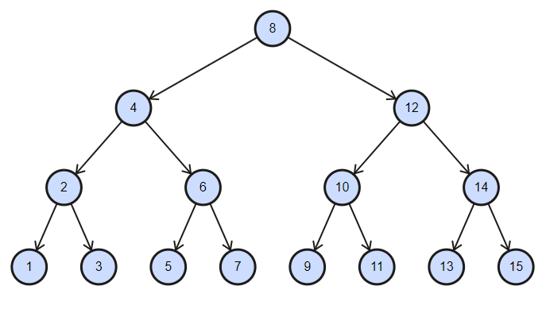

2p e) Draw a sketch with a hash table that is implemented using chaining and has the elements 6, 3, 4, 7 and 8. The hash function is H(k) = k % 3.
Exercise 4
5 min
1p a) Draw a graph for which the BFS is “5 2 9 1 3 7”.

1p b) Write the BFS for following graph starting with node 1. Smaller nodes will be processed first.
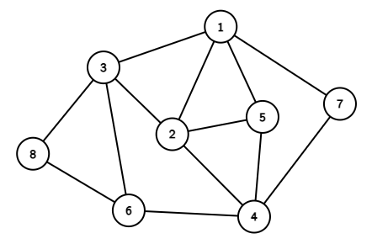

1p c) Write the DFS of the following graph starting with node s. Process nodes in alphabetical order: C E R S T U.
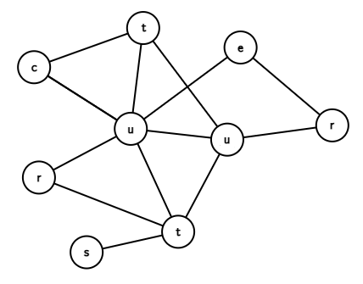

Exercise 5
7 min

4p a) In a Binary Search Tree, nodes are represented as integers. Write an algorithm that searches for an element in the tree and has the following signature:

Node *find(Node *root, int key);

3p b) Describe a method to find if there is a loop in a Singly Linked List with N elements.
Partial 1 rules:
- There is a good chance you won’t have time to solve all the exercises. Solve as many as you can in the given time slot. You can get a high grade without solving everything.
- Write on the sheet of paper only what is required. Do not copy the code written in the document containing the exercise description.
- Write your name on all the papers used to solve the exercises.
- This exam is open-book. You can use any resource. Collaboration is strictly prohibited. Discord, Skype, Google Meet or any other kind of service that enables collaboration during the exam is forbidden.
- Exams that have weird/similar/outrageous answers will be canceled and the student will have to retake the exam.
- For each exercise you will have a certain time slot allocated + 2 minutes to photograph and upload the picture on Github.
- Make sure you are on the “partial” branch. After pasting an image named “exercise_#.png/jpg” in the “partial” folder, use git add . , git commit -m “exercise #” and git push.
- If you encounter git problems during the exam you are the one responsible for solving them. We’ve been using Git for half a semester now, not knowing these basics will make you eligible for failing the partial exam.
- You will have to add, commit, and push after each exercise.
- Commits submitted after the time slot has ended will not be graded.
- I will share with you a PDF file containing exercise N after starting the timer. I will announce when the time slot has ended and I will start the timer for 2 extra minutes for you to upload the photographs. We will take a short break after which we continue with exercise N+1.

There are 5 exercises. Here’s the weight of each exercise:
5 min 1. a) 3 p b) 1 p
12 min 2. a) 4 p b) 2 p
6 min 3. a) 1 p b) 1 p c) 1 p d) 1 p e) 2 p
5 min 4. a) 1 p b) 1 p c) 1 p
7 min 5. a) 4 p b) 3 p
Total work-time: 35 min
Total points: 26 p
You need at least 13 p to pass this exam.

Conversion function from points to the actual grade is not linear and will be announced at a later time after the exam.

